IdeationPhase LiteratureSurvey

|  |  |
| --- | --- |
| **Date** | 15 oct 2022 |
| **Team ID** | PNT2022TMID42862 |
| **Project Name** | Personal Expense Tracker Application |

Literature Survey

A **literature survey** is an overview of the previously published works on a specific topic. The term can refer to a full scholarly paper or a section of a scholarly work such as a book, or an article.

A good literature review can ensure that a proper research question has been asked and a proper theoretical framework and/or research methodology have been chosen.

# Abstract

Personal Expense Tracker is a day-to-day expense management Application designed to easily and efficiently track the daily expenses done via both online and offline through a computerized system that eliminates the need for manual paper tasks that systematically maintains records and easily accesses data stored by the user.

# Introduction

An expense tracker is a software or application that helps to keep an accurate record of your money inflow and outflow. Many people in India live on a fixed income, and they find that towards the end of the month they don't have sufficient money to meet their needs.Some of these apps also offer budgeting tools, credit monitoring, mileage tracking, receipt keeping, and advice to grow your net worth.

# Survey

Most people spend less than half of their income. Very few people track their expenses on a regular basis. MS Excel is the most popular expense tracking tool.

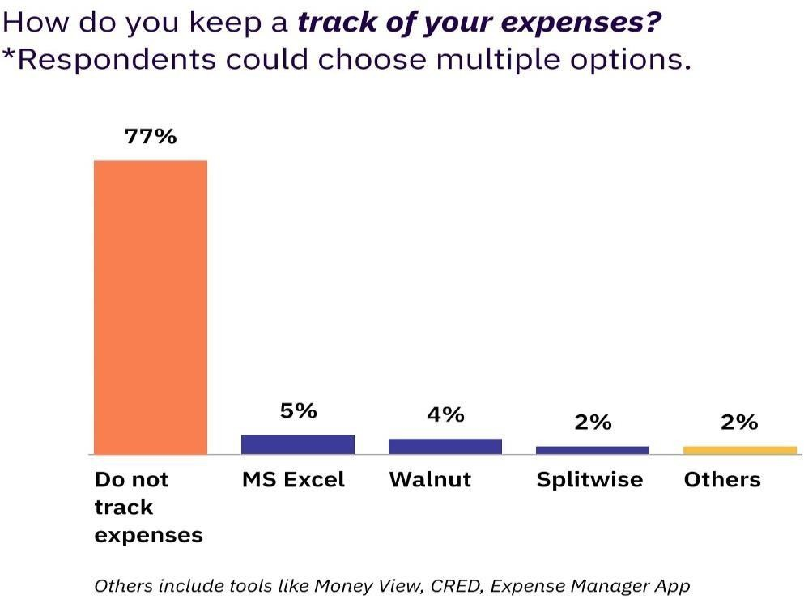

# Existing Solutions :

**Money View - Expense Manager App**

Money View App reads all of the transactional SMS messages and provides you with real-time visibility into your finances. This app unearths the hidden financial data

that sits idly in SMS logs and makes excellent use of it.

# Key features of the App:

* Check your bank account balances.
* See the most recent banking transactions.
* The Money View app automatically categorise your payments and displays major areas of spending.
* View weekly and monthly summaries to help you avoid overspending and improve the efficiency of your budget planning.
* It keeps track of your spending, sends personalised bill-paying reminders, finds relevant savings opportunities, and much more.
* Track your financial progress by looking at your spending trends over time.

# Good budget - Budget & Finance App :

This personal finance manager app acts as a proactive budget planner, assisting you in staying on top of your budget, bills, and finances. The personal finance app was

designed for simple, real-time budget and financial tracking, making it one of the best expense tracker apps in India.

# Key Features of the App:

* Data is backed up automatically and securely to Good budget's website.
* Dis aggregate expense transactions
* Transactions that are scheduled and envelope fills
* Save time by using intelligent payee and category suggestions.
* Transfer funds between Envelopes and Accounts with ease.
* Match the budget period to the real-life situation.
* Analyse spending with the Spending by Envelope Report.
* Use the Income vs. Spending Report to keep track of your cash flow.
* Export transactions to CSV
* Carryover any unused funds to the next month as a reward for your incredible self-control.
* Plan your finances ahead of time to stay on track with your budget.

# References

* <https://moneyview.in/loan-insights/best-money-management-apps-in-india>
* [https://www.factmr.com/media-release/2355/global-personal-finance-mobile-app-](https://www.factmr.com/media-release/2355/global-personal-finance-mobile-app-market) [market](https://www.factmr.com/media-release/2355/global-personal-finance-mobile-app-market)
* <https://relevant.software/blog/personal-finance-app-like-mint/>
* [https://www.onmanorama.com/lifestyle/news/2022/01/11/financial-literacy-](https://www.onmanorama.com/lifestyle/news/2022/01/11/financial-literacy-trend-among-todays-youth-investment.html) [trend- among-todays-youth-investment.html](https://www.onmanorama.com/lifestyle/news/2022/01/11/financial-literacy-trend-among-todays-youth-investment.html)
* [https://www.livemint.com/money/personal-finance/96-indian-parents-feel-](https://www.livemint.com/money/personal-finance/96-indian-parents-feel-their-children-lack-financial-know-how-survey-1166133611085.html) [their- children-lack-financial-know-how-survey-1166133611085.html](https://www.livemint.com/money/personal-finance/96-indian-parents-feel-their-children-lack-financial-know-how-survey-1166133611085.html)
* [https://economictimes.indiatimes.com/small-biz/money/importance-of-financial-](https://economictimes.indiatimes.com/small-biz/money/importance-of-financial-literacy-amongst-youngsters/articleshow/85655134.cms) [literacy-amongst-youngsters/articleshow/85655134.cms](https://economictimes.indiatimes.com/small-biz/money/importance-of-financial-literacy-amongst-youngsters/articleshow/85655134.cms)